Water Festival – To Honor Naval Forces

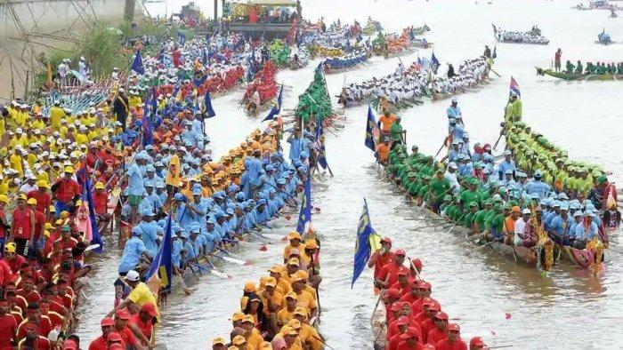

A true water culture, Cambodia’s ancient relationship between the Mekong, the people and the land dates back thousands of years. The famed navies of the Angkorian Kings fought and won many a battle on the waters of the Mekong and the Tonle Sap, and these mighty rivers have given life to some of the greatest Empires in Asia.

The water festival is a celebration of the rebirth of the country through the monsoon rains, and the colorful boat races a vestige of the former military might of Angkor.

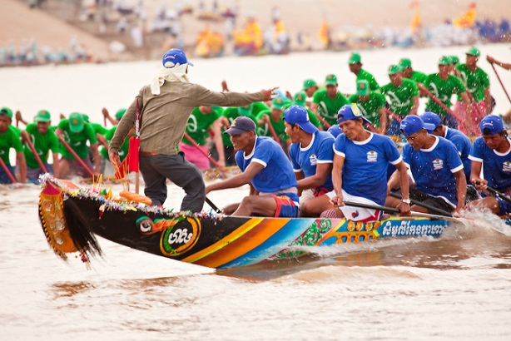

Dating back to Angkorian times, today’s Water Festival is a throwback to times past. Originating as a Khmer thanksgiving ceremony to celebrate the end of the monsoon, kick off the Cambodian fishing season and appease the river divinities, the Water Festival was also seen as a showcase of military prowess, with the 12th century victories of King Jayavarman VII immortalized in the colorful boat racing traditions and adorned upon the walls of the Bayon and Banteay Chhmar Temples.

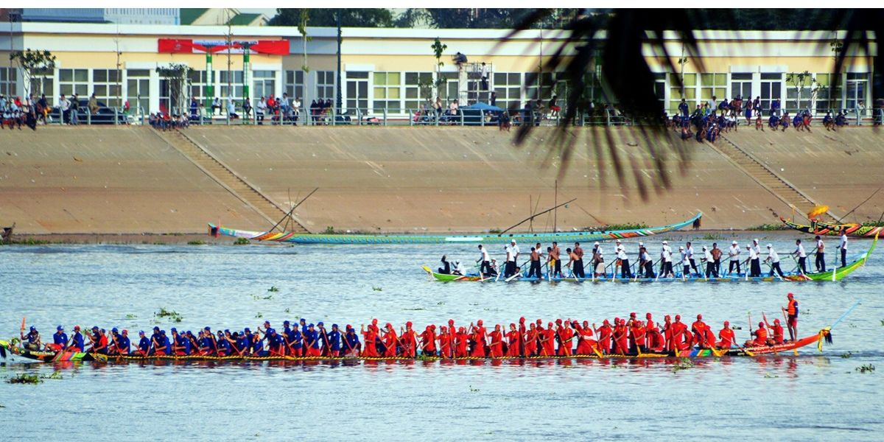

Water festival Cambodia is a magnificent and traditional event which take place at Phnom Penh. The Cambodia Water Festival history dates back to 12th century of Angkor period when the Naval Forces had battled for securing Cambodia.

It is a mark of respect for these Naval Forces. It is celebrated night and day with all the Cambodian citizens, peasants and foreign travelers gathering in the capital. A boat racing event takes place during the celebration which formerly was a battle training conducted by the naval forces.

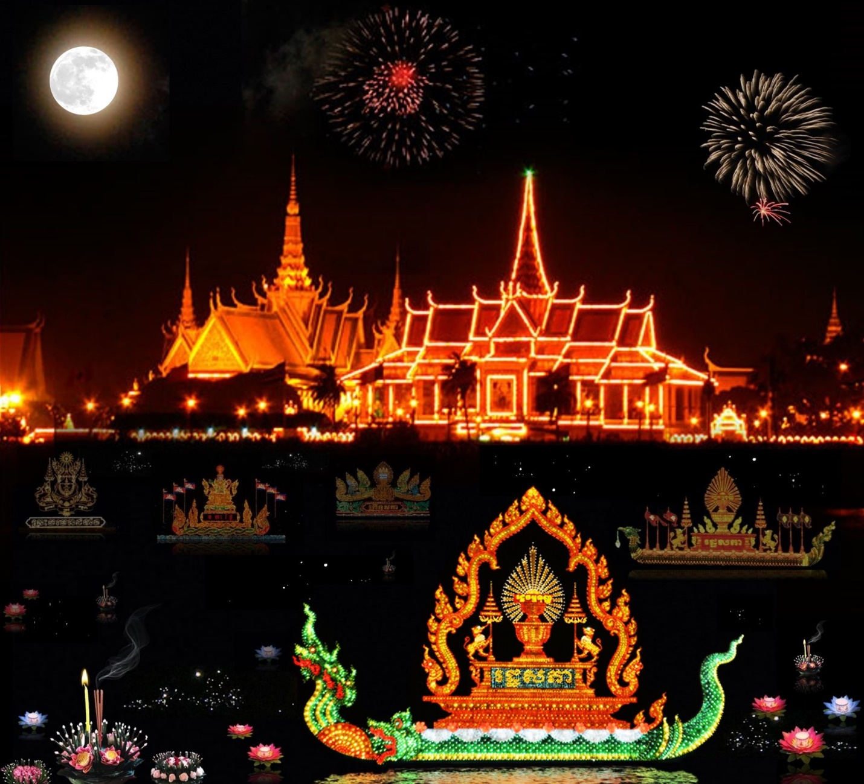

As well as the boat racing, there are three other traditional pillars of the Water Festival to celebrate and give thanks to both the land and water

**When:**13th April to 15th April 2020